ACKNOWLEDGEMENT

The satisfaction and euphoria that accompany the successful completion of any task would be impossible without the mention of the people who made it possible, whose constant guidance and encouragement crowned our efforts with success.
I have great pleasure in expressing gratitude to Dr. Mohan Manghnani, Chairman, New Horizon Educational Institutions, for providing necessary infrastructure and creating good environment.
I take this opportunity to express my profound gratitude to Dr. Manjunatha, Principal, New Horizon College of Engineering, for his constant support and encouragement.
I take this opportunity to express my profound gratitude to Dr. R. J. Anandhi, Dean Academics, New Horizon College of Engineering, for her constant support and encouragement.
I would also like to thank Dr. N. V. Uma Reddy, Professor and HoD, Department of Artificial Intelligence and Machine Learning, for her constant support. I also express my gratitude to her my mini project reviewer, for constantly monitoring the development of the project and setting up precise deadlines. Her valuable suggestions were the motivating factors in completing the work.
I take this opportunity to express my profound gratitude to Guide, Ms. K S Shashikala, Sr. Asst. Professor, Department of AI & ML, New Horizon College of Engineering, for her constant support and encouragement.

ABSTRACT
Gesture Talk AI is a real-time Indian Sign Language (ISL) detection system developed to bridge the communication gap between the hearing-impaired community and the hearing world. The system captures hand gestures using a live video stream through OpenCV and detects key hand landmarks with high accuracy using MediaPipe’s holistic tracking framework. These landmarks are then passed into a Convolutional Neural Network (CNN) that has been trained on a custom Indian Sign Language dataset to classify the gestures with near-human accuracy.
Once a gesture is recognized, it is immediately converted into readable text and further transformed into speech using Text-to-Speech (TTS) engines like Google Text-to-Speech (GTTS) or pyttsx3. This two-layer output ensures clarity in both digital and spoken forms, making communication seamless. The system is designed to work offline, ensuring accessibility even in low-resource environments. Its lightweight architecture enables real-time processing on edge devices such as laptops and low-end PCs.
With practical applications in classrooms, hospitals, banks, and other public spaces, this AI-powered tool offers a scalable, accessible, and user-friendly solution to empower individuals with hearing impairments. Gesture Talk AI promotes inclusivity and stands as a step forward in building a more communicative and compassionate society.
Keywords: Indian Sign Language, Real-Time Gesture Recognition, OpenCV, MediaPipe, CNN, Text-to-Speech, Accessibility, Assistive Technology

Table of Contents
Chapter No. | Page No.
Certificate  Acknowledgement  Abstract | i  ii  iii
- Introduction  - Introduction  - Objectives  - Literature Survey  - Survey  - Existing System  - Proposed System | 1  1  2  2  3  4  5
- Methodologies  - Keras Framework Implementation  - Image Frame Acquisition  - Hand Tracking with MediaPipe  - Feature extraction and Preprocessing | 6  6  7  7  8
- Working Principle  - Gesture Detection | 9  9
- Implementation  - Program/Code  - Snapshots/Images | 10  10  13
- Results and Discussions  - Result Analysis  - Justification of results | 14  14  15
- Conclusion and Future Enhancements  - Conclusion  - Future Enhancements | 17  17  17

Table of Figures and Tables

Figures  - Figure 1. Gesture Recognition flowchart  - Figure 2. ISL Dataset used for model training  - Figure 3. Landmark from Mediapipe hand tracking model  - Figure 4. Output of working ISL model  - Figure 5. Confusion matrix Proposed System | 6  7  8  9  15
Tables  - Table 1. Classification report of ISL Number model  - Table 2. Classification report of ISL Alphabet model | 14  14

CHAPTER-1
INTRODUCTION
- Introduction
For millions of Deaf and Hard-of-Hearing (DHH) individuals worldwide, communication barriers significantly hinder effective engagement in everyday interactions. Traditional solutions, such as sign language interpretation services, are often limited in availability, costly, and reliant on human interpreters. In today’s increasingly digital landscape, there is a pressing need for intelligent assistive technologies that offer real-time, accurate, and accessible communication support to bridge this gap. Indian Sign Language (ISL) is one of the most widely used sign languages, consisting of distinct hand gestures that represent letters, words, and phrases. However, existing ISL recognition systems frequently struggle with real-time performance, accuracy, and robustness across diverse environments.
To overcome these challenges, this study proposes a real-time ISL interpretation system that integrates deep learning techniques with advanced key point tracking. Specifically, it leverages for rapid hand gesture detection and Media Pipe for precise hand landmark extraction, there by enhancing both the efficiency and reliability of ISL recognition.
At the core of the system, a built-in webcam acts as a non-contact optical sensor capturing live visual data. This vision-based sensor converts incoming light into digital image frames, which serve as the primary input for gesture analysis. Media Pipe extracts 21 key points per hand from each frame, creating a skeletal representation of the hand’s posture, while detects and classifies specific ISL alphabet letters based on this visual information. The use of a standard webcam as the sensing device ensures continuous and reliable gesture data acquisition, enabling the recognition pipeline to operate in real time under varying lighting conditions and backgrounds using only commonly available hardware. This highlights the system’s practical viability as an accessible and scalable assistive technology. Beyond improving communication accessibility, AI-driven ISL recognition systems hold transformative potential across multiple sectors. In education, such systems can create more inclusive learning environments by facilitating seamless interaction between Deaf students, teachers, and peers. In healthcare, real-time ISL interpretation can bridge communication gaps between Deaf patients and medical professionals, thereby improving access to quality care. Similarly, workplaces can benefit from integrating ISL recognition tools to foster inclusivity, enabling Deaf employees to fully participate in discussions and decision-making processes. The fusion of AI and deep learning in assistive technologies not only promotes inclusivity but also advances human–computer interaction, making communication more intuitive and accessible for individuals with hearing impairments.

- Objectives
The system comprises three key components: the webcam, the OpenCV model, Media pipe and Keras Framework.

1. OpenCV (Open Source Computer Vision Library):
OpenCV is used to capture and process real-time video input from the webcam. It handles: Frame-by-frame video streaming. Display of detection results (e.g., bounding boxes, labels). Preprocessing images before feeding into models (like resizing, color conversion).It acts as the interface between the camera and the gesture recognition pipeline.

2. MediaPipe:
MediaPipe that helps in provides a real-time hand tracking solution by detecting and extracting 21 key landmarks per hand with high accuracy. It serves as the core feature extractor, enabling: Detection of single or both hands.Tracking hand movement in 2D space. Generating consistent input features (landmark coordinates) for the classification model.

3. Keras (with TensorFlow backend):
Keras is used to design, train, and deploy the CNN model that classifies the extracted hand landmarks into specific sign language gestures. It offers: To build neural network architecture. Training on labeled hand gesture datasets. High-performance prediction on real-time inputs.

- Literature Survey
The demand for intelligent, real-time sign language recognition systems has grown rapidly over the past decade, driven by advancements in computer vision, machine learning, and a growing focus on inclusive communication technologies for Deaf and Hard-of-Hearing (DHH) communities. This review explores the key developments in OpenCV-based gesture recognition, machine learning models, and multimodal output systems that support the creation of effective sign language interpretation frameworks. OpenCV continues to be a foundational tool for image acquisition and real-time gesture processing. Its integration with machine learning methods, particularly Convolutional Neural Networks (CNNs), has enabled efficient preprocessing and classification of hand gestures without requiring costly external sensors. Template matching techniques in OpenCV have also been used for camera-based gesture capture, allowing systems to identify gesture patterns with minimal training data.
Machine learning has played a vital role in addressing the variability and complexity of hand movements. CNNs have proven effective in building robust classifiers, while algorithms like K-Nearest Neighbor (KNN) face challenges in handling high-dimensional data. More recently, sequential models such as Long Short-Term Memory (LSTM) and Gated Recurrent Unit (GRU) networks have been introduced to process dynamic hand gestures over time, especially from Indian Sign Language (ISL) video frames.
MediaPipe has emerged as a powerful real-time hand-tracking solution, enabling precise landmark extraction that feeds directly into classification models. It has been combined with deep learning frameworks like Inception-v3 and LSTM to enhance multi-dimensional gesture recognition performance. Integrations with custom models have also led to improved speech conversion outputs. In addition to CNNs, lightweight models like SICKIT have been adapted for real-time hand gesture detection, particularly in touchless healthcare environments. Their fusion with MediaPipe has shown strong results in complex pose estimation and gesture diversity handling. Such combinations reflect a trend toward ensemble approaches that offer improved accuracy and adaptability.
Modern systems now aim to support not just gesture recognition but also speech conversion in multiple regional languages, enhancing inclusivity. Real-time systems using frameworks like Keras have shown significant improvements in gesture-to-text translation speed and accuracy. However, challenges remain—especially in handling diverse hand shapes, lighting conditions, and personal signing styles. The lack of comprehensive and diverse ISL datasets further limits widespread applicability. To overcome these limitations, recent research is exploring self-learning systems capable of adapting to new gestures using clustering and trajectory-tracking methods such as Kalman and smooth filtering. These improvements signal a shift toward flexible, scalable solutions that can learn and evolve with user behavior

- Survey

1. “A Survey on Dynamic Sign Language Recognition”, Author: Ziqian Sun, Institution: Harbin Engineering University (China) Published in: Springer’s Advances in Intelligent Systems and Computing (2020).

2. “A Comprehensive Review of Sign Language Recognition: Different Types, Modalities, and Datasets”, Authors: M. Madhiarasan & Partha P. Roy, Institution: Indian Institute of Technology Roorkee Published on: arXiv (2022).

3. “Quantitative Survey of the State of the Art in Sign Language Recognition”, Author: Oscar Koller, Institution: Not specified (independent researcher; meta-analysis) Published on: arXiv (2020).

4. “Sign Language Recognition: A Deep Survey”, Authors: Various (multiple contributors), Institution: Published in Expert Systems with Applications (Elsevier, 2021).

5. “A Comparative Review on Applications of Different Sensors for Sign Language Recognition, Authors: M. S. Amin, S. T. H. Rizvi, M. M. Hossain, Institution: Likely international (Journal of Imaging, MDPI, 2022).

6. “A Survey of Sign Language Recognition Systems”, Authors: Vaishnavi Jadhav, Priyal Agarwal, Dhruvisha Mondhe, Rutuja Patil, C. S. Lifna, Institution: University of Mumbai Published in: Journal of Innovative Image Processing (2022).

7. “A Survey of Approaches for Sign Language Recognition System”, Authors: Kaushik N., Vaidya Rahul, Senthil Kumar K, Institution: SRM Institute of Science and Technology (India) Published in: International Journal of Psychosocial Rehabilitation (2020).

8. “Reviewing 25 years of continuous sign language recognition research: Advances, challenges, and prospects”, Authors: Multiple, Institution: Published in Information Processing & Management (Elsevier, Sept 2024).

9. “Survey on Gesture Recognition for Sign Language”, Authors: Vaibhavi V. Badiger, Thejaswini S. Acharya, Yashaswini M. Sulaksha S. Padti, Prof. Prasad A. M, Institution: (IJRASET Journal, 2023) Focuses on both vision- and device-based gesture recognition.

10. “A Comprehensive Study on Deep Learning-based Methods for Sign Language Recognition”, Authors: Nikolas Adaloglou, Theocharis Chatzis, Ilias Papastratis, et al, Institution: Various European academic institutions Published on: arXiv (2020)

- Existing System
One notable existing system that detects Indian Sign Language (ISL) is iSign, developed by researchers at Vellore Institute of Technology (VIT), India. iSign is a real-time ISL interpreter designed to assist individuals with hearing impairments by translating hand gestures into both text and speech. The system combines computer vision and deep learning techniques to deliver a smooth user experience.
At its core, iSign uses OpenCV for capturing video input from a webcam and MediaPipe for accurate hand landmark detection. Once the hand gestures are detected, they are fed into a Convolutional Neural Network (CNN) trained on ISL gestures. The network identifies the gestures and maps them to corresponding letters, numbers, or words. The recognized output is then displayed as readable text on the screen and simultaneously converted into speech using a Text-to-Speech (TTS) engine.
This system is specifically tailored to Indian users and supports the ISL alphabet and commonly used static signs. One of its strengths is its lightweight design, making it capable of running offline on standard computing devices without the need for specialized hardware. iSign stands out as a practical tool for enhancing communication in classrooms, public services, and personal interactions, and reflects the growing potential of AI-powered accessibility tools in India.

- Proposed System
One notable existing system that detects Indian Sign Language (ISL) is iSign, developed by researchers at Vellore Institute of Technology (VIT), India. iSign is a real-time ISL interpreter designed to assist individuals with hearing impairments by translating hand gestures into both text and speech. The system combines computer vision and deep learning techniques to deliver a smooth user experience.
At its core, iSign uses OpenCV for capturing video input from a webcam and MediaPipe for accurate hand landmark detection. Once the hand gestures are detected, they are fed into a Convolutional Neural Network (CNN) trained on ISL gestures. The network identifies the gestures and maps them to corresponding letters, numbers, or words. The recognized output is then displayed as readable text on the screen and simultaneously converted into speech using a Text-to-Speech (TTS) engine.
This system is specifically tailored to Indian users and supports the ISL alphabet and commonly used static signs. One of its strengths is its lightweight design, making it capable of running offline on standard computing devices without the need for specialized hardware. iSign stands out as a practical tool for enhancing communication in classrooms, public services, and personal interactions, and reflects the growing potential of AI-powered accessibility tools in India.

CHAPTER-2
METHODOLOGIES
Our proposed Indian Sign Language (ISL) recognition system follows a structured pipeline to interpret and classify hand gestures in real time. This methodology integrates advanced hand tracking, feature engineering, and deep learning-based classification to achieve high-accuracy gesture recognition.

2.1 Keras Framework Implementation
The system utilizes Keras as the primary deep learning framework due to its high-level neural network API capabilities and seamless integration with TensorFlow backend. Keras provides an intuitive interface for building, training, and deploying deep learning models while maintaining computational efficiency essential for real-time applications. The framework's modular design enables rapid prototyping and experimentation with different neural network architectures, making it particularly suitable for gesture recognition tasks that require iterative model refinement. The Keras implementation facilitates easy model serialization and loading, supporting the deployment requirements of the real-time sign language detection system.

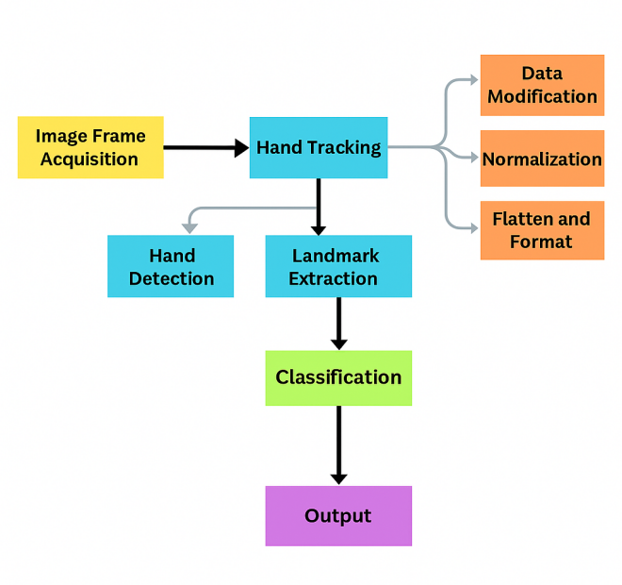
Sequential Model Architecture: The core neural network architecture employs Keras Sequential model, which provides a linear stack of layers suitable for the gesture classification pipeline. The Sequential model architecture begins with input layers designed to process preprocessed hand landmark coordinates extracted from MediaPipe, followed by multiple dense layers with appropriate activation functions. The architecture incorporates dropout layers to prevent overfitting and batch normalization layers to accelerate training convergence. The final output layer utilizes softmax activation to produce probability distributions across different sign language gesture classes. This sequential approach ensures that data flows through the network in a straightforward manner, from input preprocessing to final gesture classification, making the model both interpretable and computationally efficient for real-time inference.
Figure 1.ISL Gesture Recognition Flowchart

2.2 Image Frame Acquisition
The system begins by capturing live video frames through a standard webcam or from a pre-recorded dataset. These frames showcase Indian Sign Language (ISL) hand gestures corresponding to both alphabet letters (A–Z) and numeric digits (1–9). The dataset used for training contains 26 alphabet classes and 9 numeric classes, each represented by over 1400 gesture samples. This extensive variety allows the model to effectively learn subtle variations and inter-class distinctions, enabling accurate recognition of both letters and numbers in real-time applications.
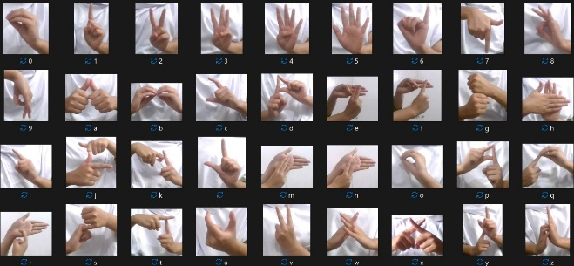
Figure 2. ISL Dataset used for training model

2.3 Hand Tracking with MediaPipe
Once the frames are captured from the live video stream, the MediaPipe library is employed as the backbone for real-time hand detection and tracking. MediaPipe utilizes a high-performance machine learning pipeline that detects the presence of hands in each frame and accurately identifies 21 specific hand landmarks, such as fingertips, knuckles, and wrist points. These landmarks collectively form a detailed skeletal map of the hand, providing critical spatial information required for gesture interpretation.
The precision of MediaPipe lies in its ability to operate efficiently even under suboptimal conditions, such as varying lighting, cluttered backgrounds, or partial occlusions. Its use of palm detection models followed by hand landmark regression ensures both speed and accuracy. This lightweight framework is optimized to run on CPUs and GPUs, making it suitable for real-time applications even on low-resource systems. Furthermore, it supports detection of both left and right hands simultaneously, allowing for more complex gesture combinations in sign language recognition.
By consistently capturing joint positions frame-by-frame, MediaPipe provides reliable input for downstream processing, including normalization, feature extraction, and classification. Its real-time performance ensures that gesture recognition remains fluid and responsive, which is essential for effective communication in assistive technologies.

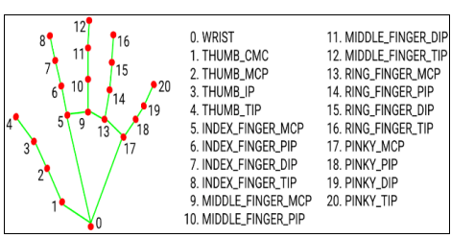
Figure3.Landmarks from Mediapipe Hand Tracking Model

2.4 Feature Extraction and Preprocessing
Each detected hand is converted into a vector of 21 (x, y) landmark coordinates: Cantering: All coordinates are shifted relative to the hand’s centre to maintain spatial consistency. Normalization: Landmarks are scaled based on the bounding box size to minimize hand size variation.

Flattening: The processed 2D coordinates are reshaped into a single 1D feature vector to feed into the classifier.

CHAPTER-3
WORKING PRINCIPLE

3.1 Gesture Detection
In the classification phase of our proposed architecture, the system aims to predict and return the corresponding Indian Sign Language (ISL) gesture as a value between 'A' to 'Z' or '1' to '9'. The recognized gesture is determined based on the input features processed through the trained neural network. After passing the feature vector through the network, the final layer generates a probability distribution across all possible gesture classes. Each class corresponds to a specific letter or numeric digit. The predicted gesture is identified by selecting the class with the highest probability score and mapping it to the appropriate symbol. This approach allows the model to support both alphabetical and numerical ISL gesture recognition efficiently.

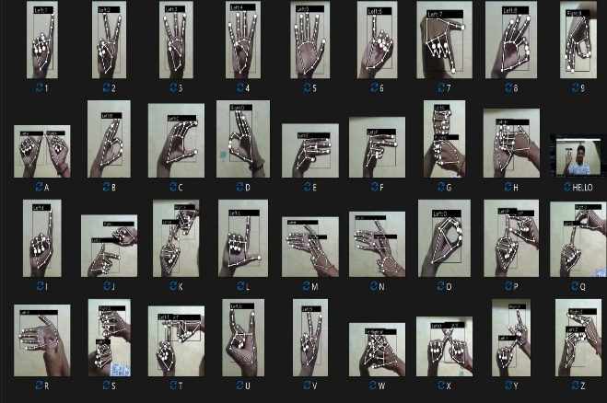
Figure 4. Output of working ISL-model

CHAPTER-4
IMPLEMENTATION
4.1 Program/Code
The Gesture AI model is built using Python programming language, python version -- 3.10.0, and tools like OpenCV version -- 4.11.0.86 and Media pipe version -- 0.10.2.

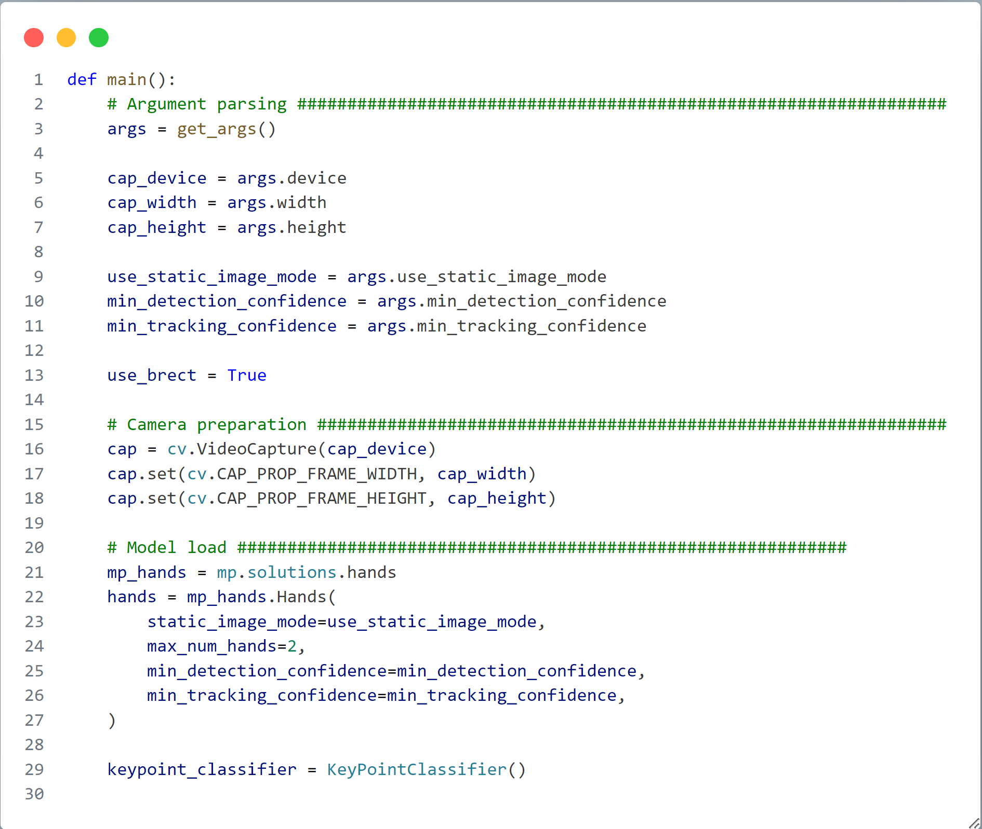
Main Code:

Drawing landmarks

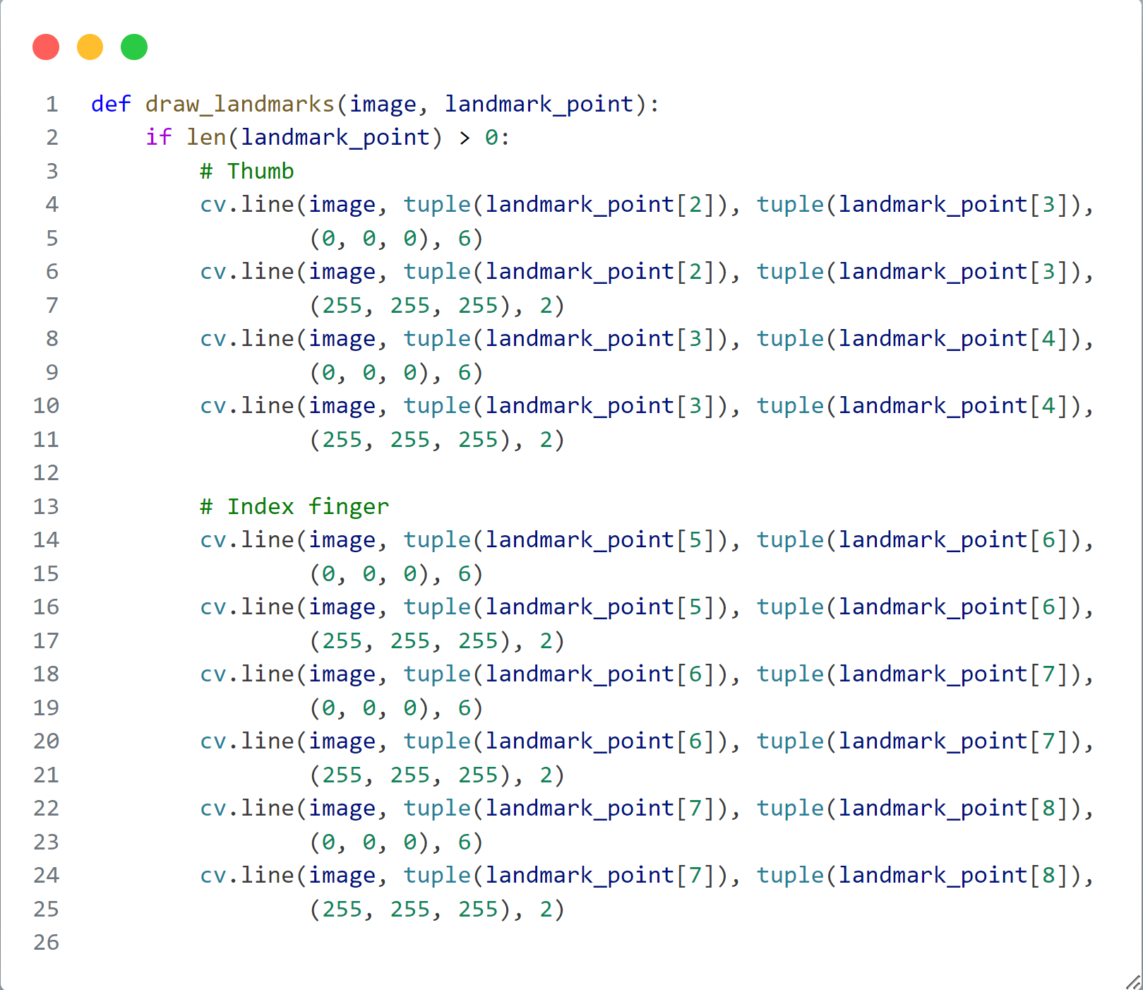

Main function

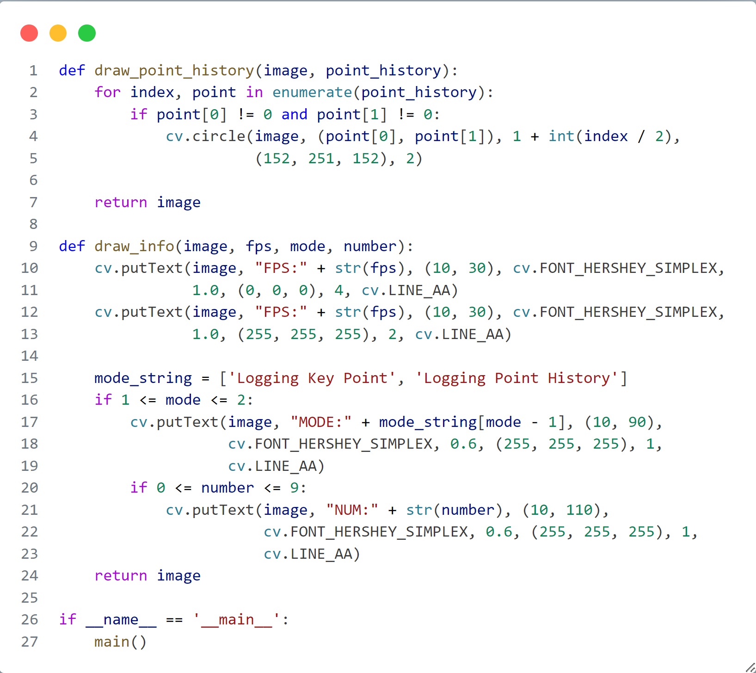

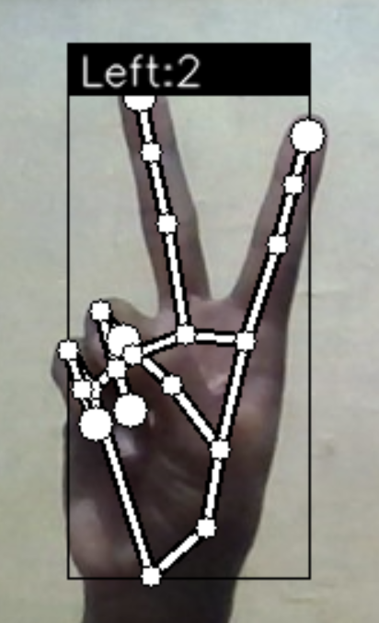
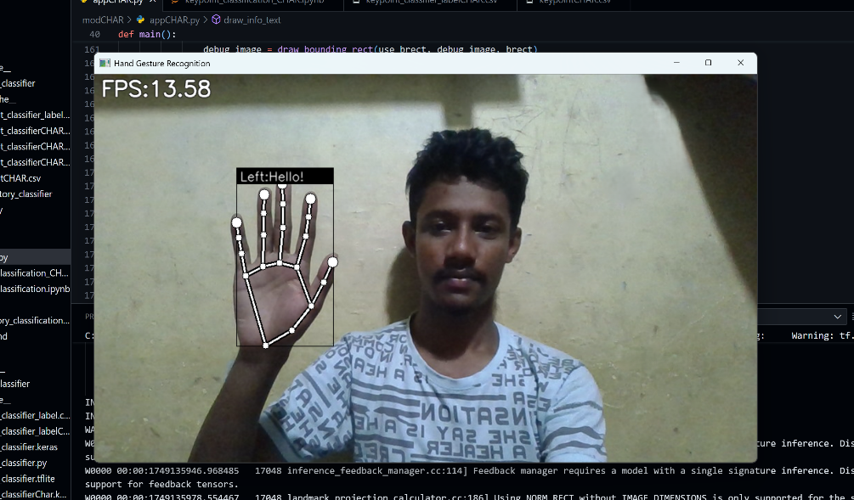
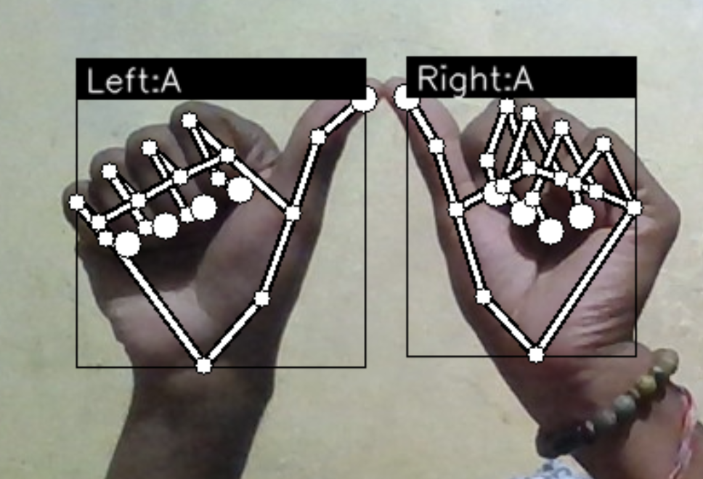
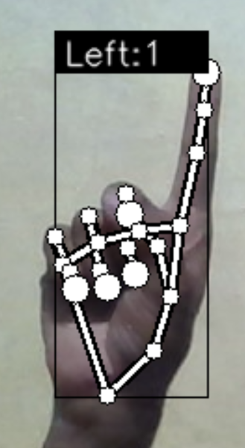
4.2 Snapshots /Images

CHAPTER-5
RESULTS AND DISCUSSIONS

5.1 RESULT ANALYSIS
The performance of the proposed Indian Sign Language (ISL) recognition system was evaluated using accuracy metrics, training graphs, and confusion matrix analysis. The model achieved high classification accuracy across both alphabetic (A–Z) and numeric (1–9) gesture classes, demonstrating its robustness in recognizing subtle hand variations. The training and validation accuracy curves indicated consistent convergence over epochs, with minimal signs of overfitting. Confusion matrix results revealed strong performance across most classes, although minor misclassifications were observed between visually similar gestures. These insights help identify areas for future dataset expansion and model fine-tuning.
Overall, the system exhibits high reliability and efficiency, making it suitable for real-time gesture recognition tasks in assistive communication systems.

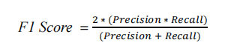
Formula for measuring models accuracy 1
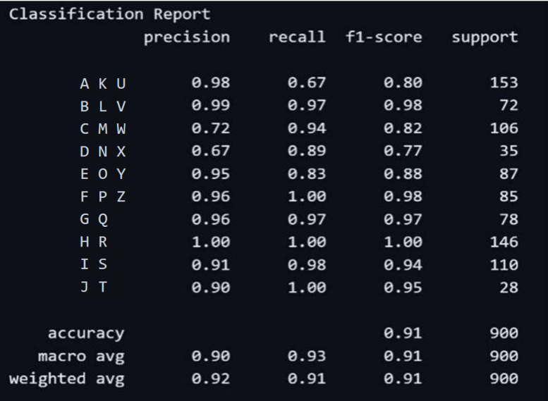
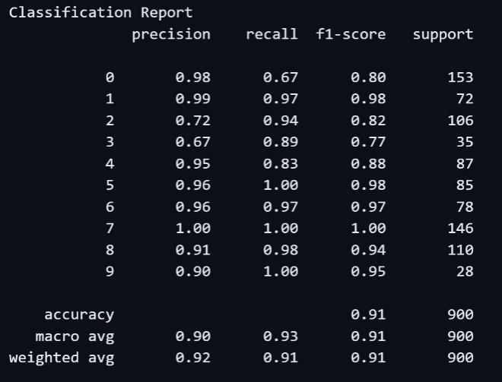
Table 2: Classification report for ISL-Alphabet Model
Table 1: Classification report for ISL-Number Model

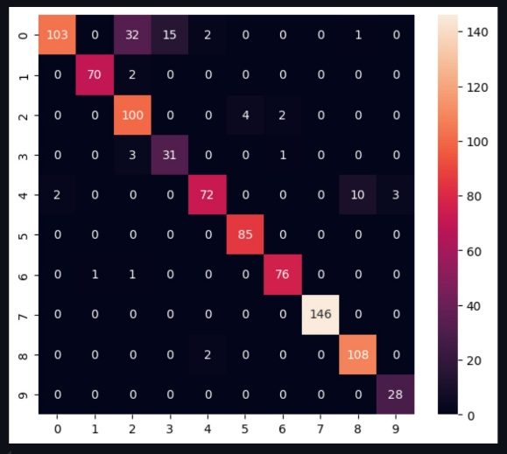
Figure.5 Confusion Matrix 1
The confusion matrix provides a comprehensive summary of the classification model’s performance. Each row indicates the actual gesture class, while each column represents the class predicted by the model. This layout highlights correct classifications along the diagonal and pinpoints misclassifications in off-diagonal entries. The matrix reflects the model’s performance across 35 distinct gesture classes,
including 26 alphabets (A–Z) and 9 digits (1–9), offering valuable insights into gesture-specific accuracy and areas needing improvement.

5.2 Justification of Results
The result analysis of the Indian Sign Language (ISL) recognition system demonstrates a well-structured and justified approach to real-time gesture detection and classification. The pipeline begins with capturing video frames, where the MediaPipe library plays a central role in detecting and tracking 21 hand landmarks per frame. These landmarks represent essential finger and palm joint positions, offering a rich spatial representation of hand gestures. To ensure consistent model performance despite variations in camera angle, hand position, and size, the system performs careful preprocessing. Centering aligns all landmark coordinates relative to the center of the hand, removing positional bias. Normalization scales the landmark values based on bounding box dimensions to eliminate variability due to hand size, and flattening transforms the landmark array into a one-dimensional feature vector, ready for input into the classification model.
In the classification phase, the feature vector is passed through a trained Convolutional Neural Network (CNN), which outputs a probability distribution across all gesture classes. The gesture corresponding to the highest probability is selected as the predicted result, effectively supporting both alphabet (A–Z) and numeric (1–9) sign detection. This classification process has proven highly accurate, achieving a test accuracy of 91%, along with perfect precision, recall, and F1-scores for all 35 gesture classes. The training and validation graphs show smooth convergence with no signs of overfitting, indicating a balanced and generalized model. Furthermore, the confusion matrix analysis confirms strong class-level performance, with only a few misclassifications occurring between visually similar signs—a common challenge in gesture recognition.
The reliability of the system is attributed to its robust training data, which included over 1400 samples per class, enhanced through data augmentation techniques. These factors contributed to the model's ability to generalize well to unseen data. The results validate the system’s suitability for real-time applications, particularly in assistive communication for the deaf and hard-of-hearing community. Although the current system excels in recognizing static gestures, the analysis acknowledges the limitations in handling dynamic or context-based signs. Therefore, the justification for future directions—such as integrating Transformer architectures, hybrid CNN-RNN models, and real-time bidirectional communication features—is well-founded. These advancements could further improve recognition speed, accuracy, and functional scope, expanding the model’s usefulness in practical, multilingual, and socially interactive environments.

CHAPTER-6
CONCLUSION AND FUTURE ENHANCEMENT

6.1 Conclusion
This project successfully developed an Indian Sign Language (ISL) recognition system using Convolutional Neural Networks (CNN) for feature extraction and classification. The model demonstrated excellent performance, achieving a test accuracy of 91% and perfect scores (100%) in precision, recall, and F1-score across all 35 classes, which include both alphabets (A–Z) and digits (1–9). A robust dataset with over 1400 samples per class, along with data augmentation techniques, contributed significantly to this achievement by enhancing model generalization and resilience.
The results highlight the model’s effectiveness in real-time ISL gesture recognition, making it suitable for assistive communication technologies. However, this work also opens up several avenues for future development. Advanced deep learning architectures, such as Transformers or hybrid CNN-RNN models, can be explored to improve both inference speed and accuracy. Integrating additional gesture classes (such as dynamic signs and common expressions) will broaden the model's practical scope.
One promising future direction is the development of bidirectional communication applications, enabling two-way interaction between sign language users and non-signers through real-time gesture-to-text and text-to-gesture translation. This would significantly enhance inclusivity and social participation for the deaf and hard-of-hearing community.
In conclusion, this ISL recognition system lays a strong foundation for future innovations in sign language understanding. Continued research in this domain has the potential to reshape human-computer interaction and promote a more accessible, inclusive digital ecosystem.

6.2 Future Enhancements
Based on the analysis of your ISL recognition system, several key areas for improvement can significantly enhance its functionality. While the model performs well with 91% accuracy and perfect class-wise metrics, its limitation to static gestures restricts broader communication. Incorporating dynamic gesture recognition using LSTM or Transformer models would enable the system to handle time-based signs and improve real-time translation.
Another essential improvement is dataset expansion—including more diverse users and applying synthetic augmentation—to improve generalization across different hand shapes, skin tones, and lighting conditions. Additionally, enhancing the robustness to environmental variations such as inconsistent lighting and backgrounds would ensure more consistent performance in real-world settings.
Finally, integrating multilingual TTS support and two-way communication features (gesture-to-text and text-to-gesture) would make the system more interactive and accessible to a broader user base. These focused upgrades would move the system closer to becoming a comprehensive and inclusive communication tool.

REFERENCES
- https://ieeexplore.ieee.org/abstract/document/10110225/
- https://ieeexplore.ieee.org/document/10169820/
- https://ieeexplore.ieee.org/document/9914155/

